Скачать эмбедед пайтон с оффиц. сайта
Скачать get-pip.py
Запустить get-pip.py
C:\Users\admin\Downloads\python-3.14> ./python.exe get-pip.py
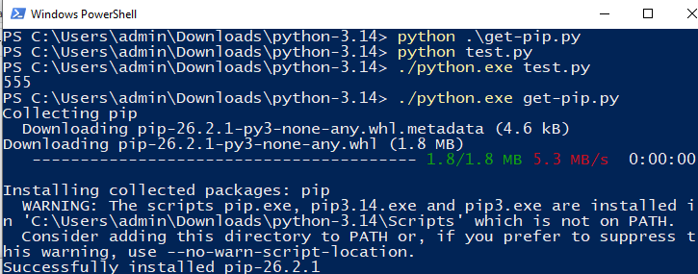
Проверка версии pip
PS C:\Users\admin\Downloads\python-3.14> ./python.exe -m pip –version
Установка pygame
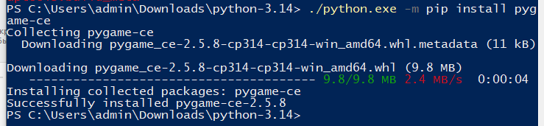

Код анимации

import pygame

# Initialize Pygame
pygame.init()
screen = pygame.display.set_mode((800, 600))
clock = pygame.time.Clock()

# Circle properties
circle_x = 400
circle_y = 300
radius = 30
speed = 5

running = True
while running:
# 1. Handle Events
for event in pygame.event.get():
if event.type == pygame.QUIT:
running = False

# 2. Update Position (Move the circle right)
circle_x += speed
#circle_y -= speed
if circle_x > 800 + radius: # Reset if it goes off screen
circle_x = -radius

# 3. Clear Screen (prevents the circle from leaving a "trail")
screen.fill((255, 255, 255)) # Fills screen with black

# 4. Draw the Circle inside the loop
# Syntax: (surface, color_rgb, (x, y), radius)
pygame.draw.circle(screen, (255, 0, 255), (circle_x, circle_y), radius)

# 5. Flip/Update the display
pygame.display.flip()
clock.tick(60) # Limits game to 60 FPS

pygame.quit()

